JUNIT

1UNIT TESTING : testing specific method or specific class

Ex: class ClassTest{

Method1

Method2

Method3

Method4

..

}

In unit testing individual test case will written for each those methods

In some secnario we will write unit case for group of methods/ unit test for specfic class

2 JUNIT

Junit will help to call this specific method check wheather output is has expected

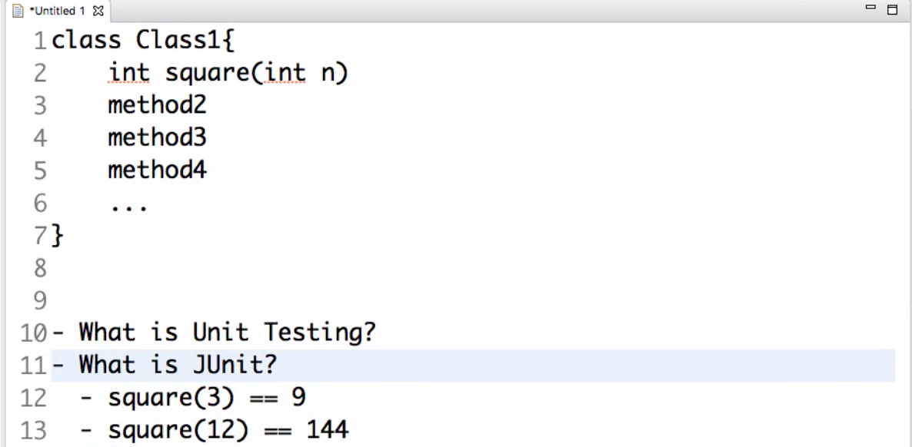

- it is an automated test we can get notification alerts if its failing when ever code modified test case will be checked

-running integration

@SpringBootTest

class BlogAppApplicationTests {

@Test

void contextLoads() {

// fail("simple fail method");

// absence of failure is success

}

}

If any of the checks fail then test case is success